Cameroon

## GNI per capita and development level

The data set shows the GNI per capita and development level of the country each year.

## # A tibble: 19 x 5  
## country iso3c date GNIperCapita devCategory   
## <chr> <chr> <dbl> <dbl> <chr>   
## 1 Cameroon CMR 1996 1016. Low Income   
## 2 Cameroon CMR 1998 1072. Lower Middle Income  
## 3 Cameroon CMR 2000 1079. Lower Middle Income  
## 4 Cameroon CMR 2002 1114. Lower Middle Income  
## 5 Cameroon CMR 2003 1162. Lower Middle Income  
## 6 Cameroon CMR 2004 1223. Lower Middle Income  
## 7 Cameroon CMR 2005 1209. Lower Middle Income  
## 8 Cameroon CMR 2006 1235. Lower Middle Income  
## 9 Cameroon CMR 2007 1249. Lower Middle Income  
## 10 Cameroon CMR 2008 1266. Lower Middle Income  
## 11 Cameroon CMR 2009 1273. Lower Middle Income  
## 12 Cameroon CMR 2010 1274. Lower Middle Income  
## 13 Cameroon CMR 2011 1290. Lower Middle Income  
## 14 Cameroon CMR 2012 1305. Lower Middle Income  
## 15 Cameroon CMR 2013 1333. Lower Middle Income  
## 16 Cameroon CMR 2014 1390. Lower Middle Income  
## 17 Cameroon CMR 2015 1421. Lower Middle Income  
## 18 Cameroon CMR 2016 1444. Lower Middle Income  
## 19 Cameroon CMR 2017 1453. Lower Middle Income

## GDP growth and economic growth classification

The data set shows the GDP growth and the ecomic growth classification of the country each year.

## # A tibble: 19 x 5  
## country iso3c date GDPannualGrowthRate GDPgrowthCategory4  
## <chr> <chr> <dbl> <dbl> <fct>   
## 1 Cameroon CMR 1996 4.36 moderate growth   
## 2 Cameroon CMR 1998 4.50 moderate growth   
## 3 Cameroon CMR 2000 3.55 moderate growth   
## 4 Cameroon CMR 2002 4.24 moderate growth   
## 5 Cameroon CMR 2003 4.57 moderate growth   
## 6 Cameroon CMR 2004 6.78 fast growth   
## 7 Cameroon CMR 2005 2.02 slow growth   
## 8 Cameroon CMR 2006 3.46 moderate growth   
## 9 Cameroon CMR 2007 4.90 moderate growth   
## 10 Cameroon CMR 2008 3.49 moderate growth   
## 11 Cameroon CMR 2009 2.20 slow growth   
## 12 Cameroon CMR 2010 3.42 moderate growth   
## 13 Cameroon CMR 2011 4.13 moderate growth   
## 14 Cameroon CMR 2012 4.54 moderate growth   
## 15 Cameroon CMR 2013 5.40 moderate growth   
## 16 Cameroon CMR 2014 5.88 fast growth   
## 17 Cameroon CMR 2015 5.65 fast growth   
## 18 Cameroon CMR 2016 4.65 moderate growth   
## 19 Cameroon CMR 2017 3.55 moderate growth

## Development trend

The plot shows the development trend of the country.

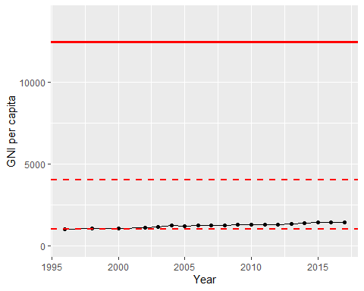

GNI Per Capita Trend